Documentation for

Colin’s Editor

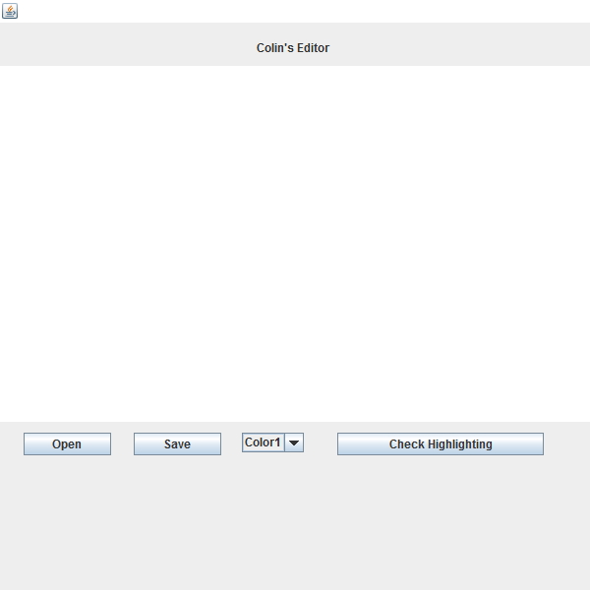

This text editor will run simple programs for our test language we have created.

To run, either compile the .java files or run the swingtest.jar file.

The editor comes with three buttons, “Open”, “Save”, “Color” “Check Highlighting”

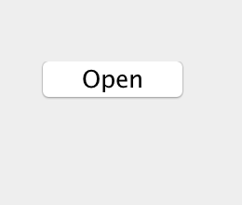

The open button loads the file directory and lets the user pick a file

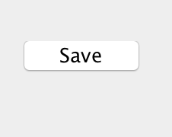

The save button allows the user to save a file to their hard disk.

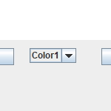

The color dropdown allows the user to change the current color scheme

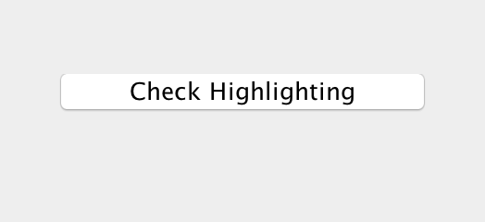

And the Check Highlighting will run our DFA against the user input to add proper highlighting.

To make a program, just write a phrase that would be accepted into our language such as “var x”. and then click our “Check Highlighting” button. If it turns green, congratulations! The program works. If it turns red, the program will not work.

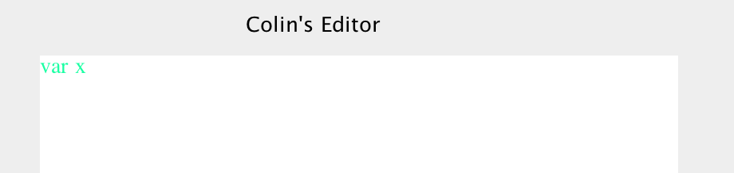

Correct!

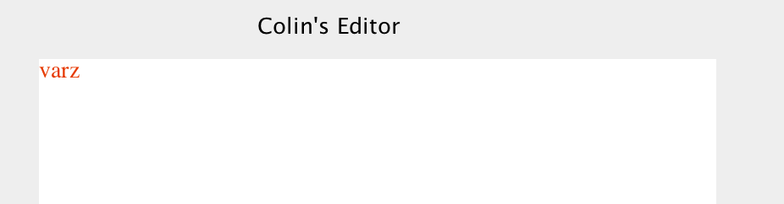

Incorrect!

Good luck with the text editor!